Lab #3: Electrical Measurements

Anthony Kosednar September 21, 2012 1:30 PM

1. **Pre-lab Questions**

1.a. I = 0.331A , V1 = 1.689V, V2 = 3.311V

1.b I1= 0.5A, I2= 0.98A, I=1.48 a

2. The I-V curve is a straight line for a resistor, and the slope is equal to the voltage divided by the resistance.

3. Diodes, along with other components, are used to construct AND and OR logic gates (diode logic).

1. **Description**

For this lab, resistors, and diodes were placed in series, and parallel and measured with a voltmeter to gather data to generate their I-V curves. In goal of the lab, was to compare the generated curves with their curves in reality.

1. **Measurements**

Include all measurements with appropriate units in the following tables.

Part 1: Resistance

|  |  |  |  |
| --- | --- | --- | --- |
| Resistor | Color Code | Theoretical Value | Measured Value |
|  | BrBlO | 10k Ohms | 9.94k Ohms |
|  | GBrR | 5.1k Ohms | 5.05k Ohms |

Part 2: Resistors in series (V=5V)

|  |  |
| --- | --- |
| Resistor | Voltage |
| R1 = 10kΩ | V1 = 3.276 V |
| R2 = 5.1kΩ | V2 = 1.667 v |

Part 3: Resistors in parallel (V=5V)

|  |  |
| --- | --- |
| Resistor | Current |
| R1 = 10kΩ | I1= 0.99 mA |
| R2 = 5.1kΩ | I2= 0.98 mA |

Part 4: I-V Curves

Resistor (R=1.1KΩ) Diode

|  |  |  |  |
| --- | --- | --- | --- |
| Voltage (0~5V with 0.5V increment) | Current | Voltage (-5~0V with 0.5V increment) | Current |
| 0.15 V | 0.00 mA | -0.15 V | 0.00 mA |
| 0.70 V | 0.13 mA | -0.70 V | 0.00 mA |
| 1.04 V | 0.46 mA | -1.04 V | 0.00 mA |
| 1.51 V | 0.86 mA | -1.51 V | 0.00 mA |
| 2.02 V | 1.31 mA | -2.02 V | 0.00 mA |
| 2.45 V | 1.7 mA | -2.45 V | 0.00 mA |
| 3.00 V | 2.19 mA | -3.00 V | 0.00 mA |
| 3.50 V | 2.64 mA | -3.50 V | 0.00 mA |
| 3.99 V | 3.08 mA | -3.99 V | 0.00 mA |
| 4.47 V | 3.52 mA | -4.47 V | 0.00 mA |
| 5.00 V | 4.01 mA | -5.00 V | 0.00 mA |

|  |  |
| --- | --- |
| Voltage (0~5V with 1V increment) | Current |
| 0.102 V | 0.14 mA |
| 1.516 V | 1.39 mA |
| 2.138 V | 1.97 mA |
| 3.101 V | 2.85 mA |
| 4.21 V | 3.87 mA |
| 5.15 V | 4.73 mA |

1. **MATLAB code and plots**
2. I-V curve for a resistor

**MATLAB Code:**

% Description: FSE 100 - Lab #3 - Post Lab - Resistor IV

% Author: Anthony Kosednar

% Date: 09/11/2012

% I-V Curve Resistor (R=1.1K Ohm)

% Define Variables

V = [0.102 1.516 2.138 3.101 4.21 5.15];

I = [0.14 1.39 1.97 2.85 3.87 4.73];

plot(V,I)

title('I-V Curve for a Resistor (R=1.1K Ohm)')

xlabel('Voltage (volts)')

ylabel('Current (mAmps)')

**Graph:**

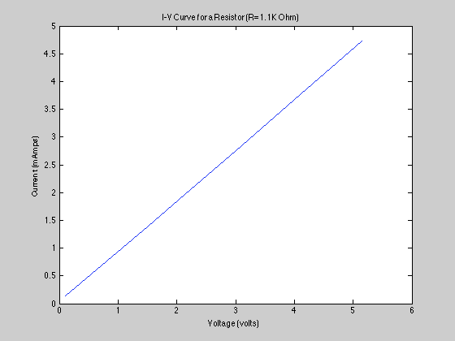

1. I-V curve for a diode

**MATLAB Code:**

% Description: FSE 100 - Lab #3 - Post Lab - Diode IV

% Author: Anthony Kosednar

% Date: 09/11/2012

% I-V Curve Diode

% Define Variables

v = [-5.0 -4.47 -3.99 -3.50 -3 -2.45 -2.02 -1.51 -1.04 -0.70 -0.15 0.15 0.70 1.04 1.51 2.02 2.45 3 3.50 3.99 4.47 5.0]

i = [0 0 0 0 0 0 0 0 0 0 0 0 0.13 0.46 0.86 1.31 1.7 2.19 2.64 3.08 3.52 4.01]

plot(v,i)

title('I-V Curve for a Diode');

xlabel('Voltage (volts)');

ylabel('Current (mAmps)');

**Graph:**

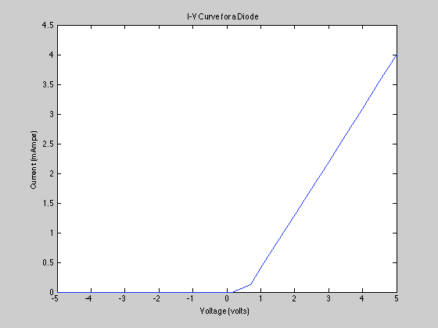

**Post-lab Questions**

1. Since our voltage is only a slightly off from the theoretical, the voltage is within an acceptable degree of error, and thus the voltage division formula holds.
2. Since our current is only a slightly off from the theoretical, the voltage is within an acceptable degree of error, and thus current voltage division formula holds.
3. The I-V curve is equal to the resistance in the resistor graph. This matches our pre-lab answer. Unfortunately, our diode graph does not meet our pre-lab graph. We believe that this might be because our multi-meter was acting up. Otherwise, it is guessed that it is forward-biased.